# Operational Concept Description (OCD)

**Team No. 3**

**Istartonmonday.com**

|  |  |
| --- | --- |
| **Team members** | **Role** |
| Kandarp Nyati | Project Manager |
| Fei Li | Operational Concept Engineer |
| Tanya Gautam | Requirement Engineer |
| Bharat Shugani | Software Architect |
| Thammanoon Kawinfruangfukul | Life Cycle Planner |
| Mark Villanueva | IIV&V |
| Ying Li | Tester |

**12/12/2011**

# Version History

| Date | Author | Version | Changes made | Rationale |
| --- | --- | --- | --- | --- |
| 09/27/11 | Fei Li | 1.1 | Section 1, 2, 3.1 | Initial draft to use |
| 10/03/11 | Fei Li, Bharat Shugani | 1.2 | Section 1.1, 2.1, 2.4, 2.5 | Version 1.1 defects resolved and additions |
| 10/07/11 | Fei Li | 1.3 | Section 1.1, 2.2, 2.3, 2.4, 2.5 | Respond to evaluation of VC package |
| 10/07/11 | Fei Li | 2.0 | Section 3.2,3.3,3.4 | Prepare for FC package submission |
| 10/14/11 | Fei Li | 3.0 | Section 2.1, 2.3, 2.4, 2.5, 3.1.1, 3.1.3, 3.2.1, 3.2.2, 3.2.4, 3.3.1, 3.3.2, 3.4.2. | Respond to evaluation of FC package |
| 10/17/11 | Fei Li | 3.1 | Section 2.2, 2.5, 3.2.1, 3.3.1, 3.4.1, 3.4.2 | Corrected it to be more consistent with win conditions. Reworded some sessions according to the template.  Updated capability and win condition after new win conditions were added. |
| 10/24/11 | Fei Li | 3.2 | Section 2.4, 3.1.3, 3.2.1,3.3.1, 3.3.2 | Respond to feedback from ARB. |
| 11/07/11 | Fei Li | 3.3 | Section 2.4, 2.5, 3.3.1 | Respond to evaluation of DC package. |
| 11/13/11 | M. Villanueva | 3.4 | Section 1.1, 2.4, 3.4.2 | - Provided more details about purpose of website and email notifications  - Reverted to an older version of the BCD |
| 12/05/11 | M. Villanueva | 4.0 | Filename, header/footer  Section 1.2 | - Rename file to reflect new phase, update header/footer  - Added relevant details about phase |
| 12/11/11 | M. Villanueva | 4.1 | Table 3 | - Added LOS-4 after comments from ARB |
| 12/12/11 | Fei Li | 4.2 | Figure 1 | Respond to the feedback from Version 4.0 |

# Table of Contents

Operational Concept Description (OCD) i

Version History ii

Table of Contents iii

Table of Tables iv

Table of Figures v

1. Introduction 1

1.1 Purpose of the OCD 1

1.2 Status of the OCD 1

2. Shared Vision 2

2.1 Success-Critical Stakeholders 2

2.2 System Capability Description 2

2.3 Expected Benefits 3

2.4 Benefits Chain 4

2.5 System Boundary and Environment 5

3. System Transformation 6

3.1 Information on Current System 6

3.2 System Objectives, Constraints and Priorities 8

3.3 Proposed New Operational Concept 11

3.4 Organizational and Operational Implications 12

# Table of Tables

Table 1: Success-Critical Stakeholders 2

Table 2: Capabilities Goals 8

Table 3: Level of Service Goals 9

Table 4: Relation to Current System 10

# Table of Figures

Figure 1: Benefits Chain Diagram 4

Figure 2: System Boundary and Environment Diagram 5

Figure 3: Current Global Business Workflow of Job Posting and Application Process 7

Figure 4: Element Relationship Diagram 10

Figure 5: Proposed Global Business Workflows of Job Posting and Application Process 11

### Introduction

#### Purpose of the OCD

The operational concept description document describes the success-critical stakeholders' shared vision of the project being undertaken. This document also outlines the capabilities of the product and discusses the benefits for different stakeholders

The operational concept description document will be used constantly throughout the project's life cycle as the proposed system is being developed based on the new operational concepts. In addition, it will be heavily used during the beginning of the project as the requirements are still being gathered and the design of the proposed system is being developed.

The success-critical stakeholders:

* Client and Maintainer, Dean L. Jones;
* 6 group members in development team including five on campus members and one off campus member;
* Job seekers who use the website to look for jobs, training, workshops, events, and supportive social service information, basically with low to moderate skill set;
* Job providers who post available jobs through the website, mostly some local large scale organization who need employee very soon, for example, Walmart, goodwill and etc.

#### Status of the OCD

The current version of OCD is at version 4.0 in development phase. The benefit chain diagram was also improved to make the casual flow more understandable. We have just finished our DCR ARB and are working to transition the system to the client before the end of the semester.

### Shared Vision

#### Success-Critical Stakeholders

Table 1: Success-Critical Stakeholders

|  |  |  |  |
| --- | --- | --- | --- |
| **Stakeholder** | **Authorized Representatives** | **Organization** | **Relation to Benefits Chain** |
| Client | Dean L. Jones | Southland Partnership Corporation | CEO of the organization, key decision maker about the requirements. |
| Maintainer | Dean L. Jones | Southland Partnership Corporation | * Approve jobs positions provided by job providers * Post available jobs on the website. * Resolve technical issues which occur on the website or software he uses. |
| Developers and IV&V | * Kandarp Nyati * Thammanoon Kawinfruangfukul * Tanya Gautam * Fei Li * Bharat Shugani * Mark Villanueva | University of Southern California | * Redesign the website * Provide functionality according to client’s requirement |
| Website users | Any job seeker who uses the website | Unemployed individuals, people with low to moderate skillset who look for a new job | * Search jobs they are interested in by key word. * Register for the website or subscribe to the website. * Employ the website to apply for jobs. |
| Job providers | Any employer who provide jobs to the website | Goodwill, Wal-Mart, and etc. | Provide available job positions to client.  Search on the website for prospective employees. |

#### System Capability Description

The current system could only provide basic functionalities for job seekers. The website to be upgraded will embrace a new user interface, which could provides website users better user experience and also will be more convenient for our client to manage and update the website. The available positions will be categorized in different fields. Moreover, this new website could achieve a better two-way communication between job providers and job seekers.

The proposed website will allow job seekers to fill in their information for registration and to claim work preference. They could also choose to only subscribe to the website and receive emails when there are new job postings.

Job providers could also set up account and post available positions on the website. They can also search potential candidates from job seekers for their positions.

When client inputs new available positions, the default expiration date will be set to 30 days later, which can also be set manually to any period of time as client wants.

The target users of this website are people with low-moderate skill sets; therefore, the website fulfills a gap for people searching for those low-moderate positions, while most of other job related websites only deal with more higher-wage jobs.

#### Expected Benefits

The redesigned website will be more convenient for the client to maintain and update.

* The client will maintain and update the website with less effort.
* Minimize any potential database crashes and keep the back-end maintenance extremely simple.
* The job seekers could find available interested positions by category or searching key word, and the application process is more efficient. Moreover, the job seekers can fill in basic information to register and claim their job preference.
* The job seekers can also choose to only subscribe to the website and receive email of updated job positions.
* The job providers are allowed to search prospective employees from job seekers who are interested in the specific field of jobs they provide.
* Better two-way communication between job seekers and job providers.

#### Benefits Chain

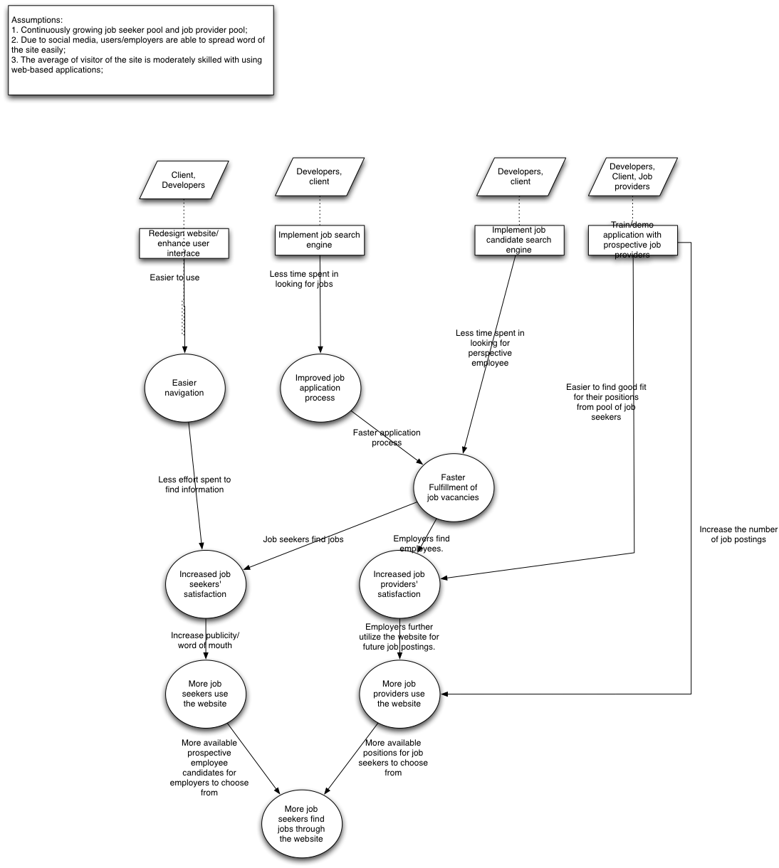

Figure 1: Benefits Chain Diagram

#### System Boundary and Environment

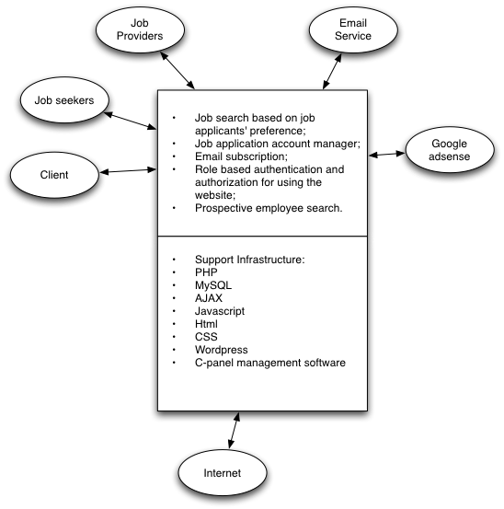

Figure 2: System Boundary and Environment Diagram

### System Transformation

#### Information on Current System

##### Infrastructure

Software  
  - Development platform: Windows  
 - Database: MySQL  
 - COTS: Wordpress  
     
Hardware  
 Internet service provider, powered by small orange panel

Intel Xeon servers with 4GB of RAM and RAID-protected 15K RPM hard drives  
 Space: 1.5 GB  
 Bandwidth: 35 GB  
 MySQL database access  
 POP3, IMAP, and web-based email access

##### Artifacts

* The job posting requests: Job providers send client request in form of emails about available job positions.
* The actual job postings in Wordpress: client post available job positions in wordpress, which will show on the website.

##### Current Business Workflow

Figure 3: Current Global Business Workflow of Job Posting and Application Process

#### System Objectives, Constraints and Priorities

##### Capability Goals

Table 2: Capability Goals

|  |  |
| --- | --- |
| **Capability Goals** | **Priority Level** |
| OC-1. **Log in page:** The website should enable users to log in based on their roles: job seekers, employers, or administrator. | Must have |
| OC-2. **Google AdSense:** Google AdSense ads from current website should maintain as they are. | Must have |
| OC-3. **Maintain employers’ links:** The website should Maintain links to other job-related sites as shown on current website. | Must have |
| OC-4. **Job seekers subscribe function:** The site should allow users to subscribe or unsubscribe from email notifications (for all job postings). | Must have |
| OC-5. **Employers’ logos:** The site should display employers’ or organizations’ logos. | Must have |
| OC-6. **Easily search for jobs:** The UI should allow the user to easily search for jobs. Jobs should be sorted into categories. The current system is just a general search. Dean and the employers determine the categories. All the categories should not be there in the front page, and it is possible to have multiple categories for one job. | Must have |
| OC-7. **Simple and intuitive user interface:** Use Wordpress, MS word/excel as a base user case. | Must have |
| OC-8. **Job provider post:** Employers have the ability to post jobs on the site. | Must have |
| OC-9. **Resemble the current website:** The main page should resemble the current site: it should contain a list of general job postings and announcements. | Must have |
| OC-10. **Key word search:** Allow key word searches on any match in the job listing. The results could pop-up any references in the job listing. | Should have |
| OC-11.**Usibility on mobile device:** The site should be usable on mobile devices: iphone, android phone, ipad, kindle, etc. (optimized for viewing on mobile devices) | Should have |
| OC-12. **Display list of employers:** Provide Dean with a list of employers and their application documents (similar to job-applications.com's layout/design) to maintain the website easily. | Should have |
| OC-13. **Default setting:** Default 30 day expiration for job postings (i.e. Remove visibility of the posting from the website) | Should have |
| OC-14. **Feedback from job seekers:** Job seekers can provide testimonials once they get the job. | Could have |
| OC-15. **Job provider registration:** The site should have a sign-up/registration page for employers, which allow them to upload jobs, add profile information. | Could have |
| OC-16. **Employer search candidate:** Employers should be able to search the job preference data of job seekers. | Could have |
| OC-17. **Job seekers registration:** The site should have a registration page for job seekers. | Could have |

##### Level of Service Goals

Table 3: Level of Service Goals

|  |  |
| --- | --- |
| **Level of Service Goals** | **Priority Level** |
| LOS-1: Security: Website uses’ information are private and need to be secured. | Must have |
| LOS-2: Usability: The system has to provide a user-friendly interface. | Must have |
| LOS-3: Accessibility: System should be accessible from anywhere with internet connections, or even on mobile device: iphone, android phone, ipad and other tablet device. | Could have |
| LOS-4: Security: All web registration forms should be checked for valid input | Must have |

##### Organizational Goals

OG-1: Provide platform for job seekers to find jobs in low to moderate skill set market.

OG-2: Help employers, or job providers to find appropriate candidates to fill in their available

positions.

OG-3: Reduce maintenance difficulty of the website.

##### Constraints

CO-1: Budget: The cost of maintaining the website should be minimized, the limitation of budget is $300/year for the cost of database needed.

CO-2: Schedule: The system should be completed within only one semester.

CO-3: Software: Since the client claimed that he is comfortable with Wordpress and does not want to learn how to use a new software, we will continue to use Wordpress to manage the website.

##### Relation to Current System

Table 4: Relation to Current System

|  |  |  |
| --- | --- | --- |
| **Capabilities** | **Current System** | **New System** |
| Roles and Responsibilities | * Client uploads positions himself. * Only job seekers can reach out to job providers, not vice versa. | * Employers also have the capability to upload positions. * Employers could also search candidates from job seekers pool, which is two-way communications. |
| User Interactions | * Job seekers can only look for jobs on the website by looking through all posts on website. | * Job seekers could search jobs in specific field by typing in key word * Job seekers can register to the website and claim work preference in the system and then apply to jobs in the future. * Job seekers could receive emails of newly posted positions. |
| Infrastructure | * Job posts only in time order. | * Job posts will be categorized according to different fields. * User-friendly graphical interface. |
| Stakeholder Essentials and Amenities | * Job providers can only wait for job seekers to reach out to them. * Job seekers cannot really keep track of their application history and could not well present themselves. | * Faster and easier information exchange between job seekers and job providers. |
| Future Capabilities |  | * The website may become profitable after more job seekers and providers appreciate its value for them to communicate. |

#### Proposed New Operational Concept

##### Element Relationship Diagram

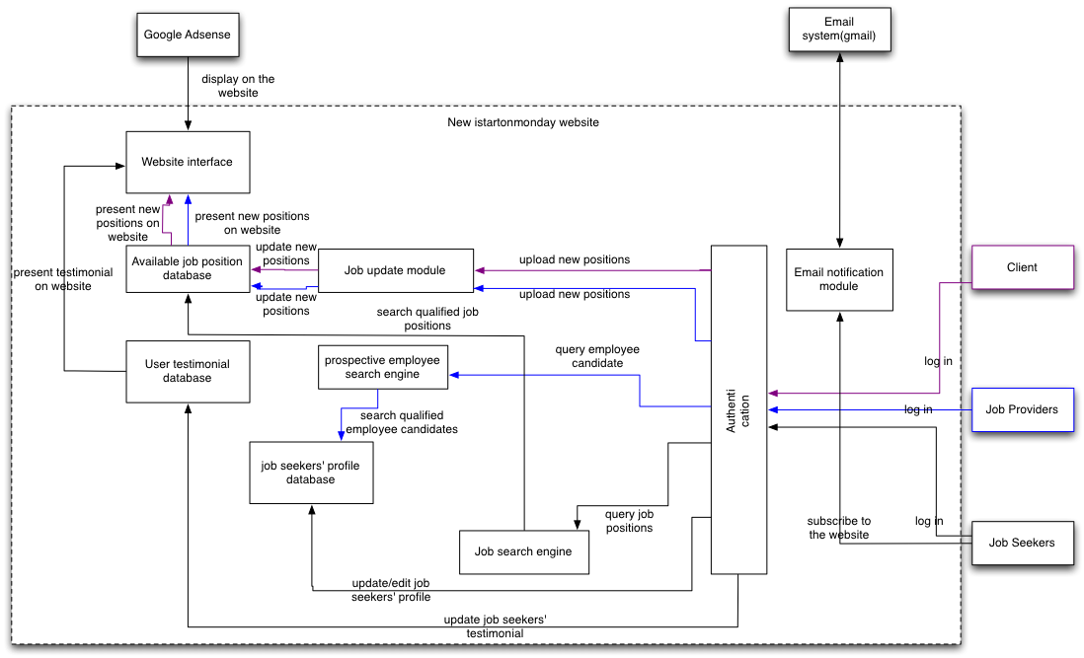

Figure 4: Element Relationship Diagram

##### Business Workflows

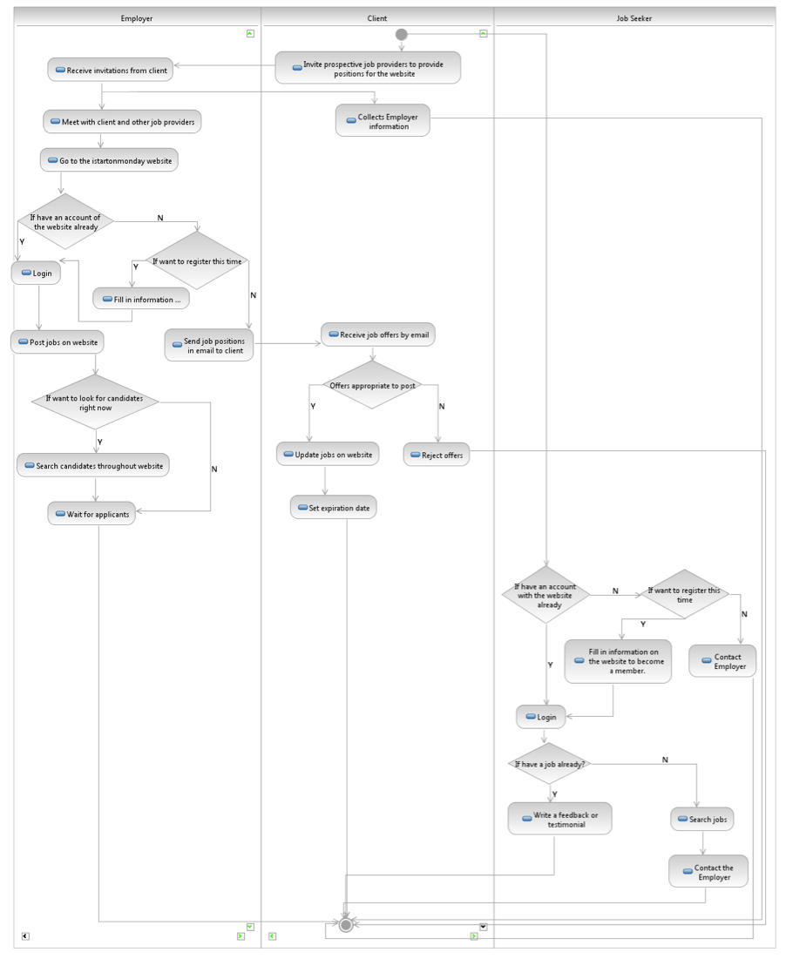

Figure 5: Proposed Global Business Workflows of Job Posting and Application Process

#### Organizational and Operational Implications

##### Organizational Transformations

* The system will contain the profiles of all the users in the database which will help the organization to match job-seekers to employers mutually in both ways;
* Instead of all anonymous visitors to the website, the system will authorize different types of users as roles will be separated like employer, admin and job-seeker.

##### Operational Transformations

* The option for all visitors to choose to subscribe to the website: subscribers receive emails (newsletter-type message) notifying users about the new updated jobs;
* The option of website registration for job seekers to claim work preference, making it possible for job providers find prospective employee, which is a more efficient two-way communication between job seekers and job providers;
* The option of website registration for job providers enabling them to edit job positions in a more quickly manner;
* The option for job seekers to search available positions in specific fields according to their interests.